EXPERIMENT 7

AIM : To write an assembly language program to implement 16 bit addition using 8085 processor.

AlGORITHM

* First load the data into AX(accumulator) from memory 3000.
* Load the data into BX register from memory 3002.
* Multiply BX with Accumulator AX.
* Move data from AX(accumulator) to memory.
* Move data from DX to AX.
* Move data from AX(accumulator) to memory.
* Stop.

PROGRAM

LHLD 2050

SPHL

LHLD 2052

XCHG

LXI H,0000

LXI D,0000

AGAIN: DAD SP

JNC START

INX B

START: DCX D

MOV A,B

ORA D

JNZ AGAIN

SHLD 2054

MOV L,C

MOV H,B

SHLD 20562

HLT

INPUT:

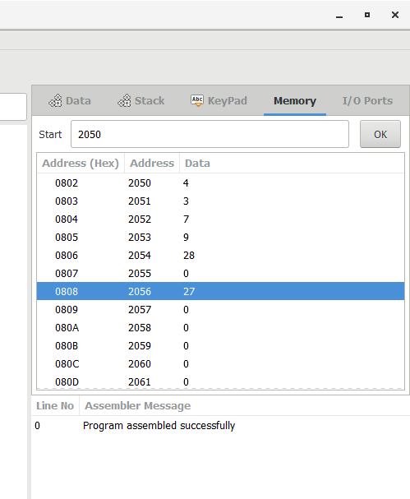

OUTPUT:

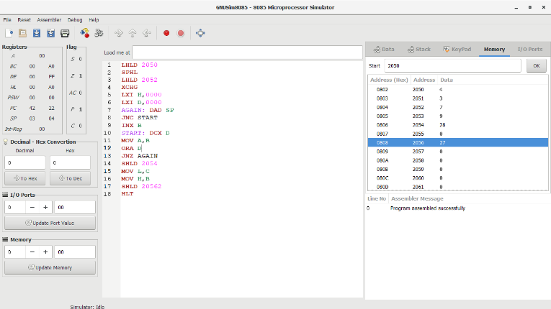

RESULT:

Thus the program was executed successfully